Meta in Head

-------------

-> meta defined meta data

-> it contains information about your application given to browser and seo

-> SEO[search Engine Optimization]

-> SEO makes your page search engine friendly

-> Search is done by "Web spiders and web crawlers"[BOTS]

-> Meta is one of the SEO feature that makes page SEO Friendly

-> Meta is also used to design responsive page.

Responsive Meta Element

<meta name=”viewport” content=”width=device-width , initial-scale=1”>

<meta http-equiv=”refresh” content=”5”>

SEO Meta Element:

<meta charset=”utf-8 | utf-16 |utf-32”>

8-Bit , 16-Bit, 32-Bit

Eng Korean arabic

China

Japan

Body Section

* The body section is defined by using <body> element
* Body is defined by using following attributes

1. bgcolor
2. background
3. text
4. align
5. alink
6. vlink
7. leftmargin
8. rightmargin
9. bottommargin
10. topmargin

Session – 03

HTML colours

1. color name
2. color hexa code

#RGB

#RRGGBB

[Dark] 0,1, 2, 3, four, 5, 6, 7, 8, 9, a, b, e, d, e, f[Bright]

1. background: it is used set background for body section

<body background=”image_path”>

Note:

* Always use only virtual path for Resources[images]
* Don't use physical path

FAQ: what is virtual path?

Ans : virtual path is the local reference path of resource in project

1. first copy of the image into your project local folders
2. access from the folder without mentioning Drive name[D,E]

E:\images \shoe.jpg Physical path

Images/shoe.jpg Virtual path

\ back slash only used in physical path

/ forward slash is used in virtual path.

../ one level back

./ same folder

Ex

1. Create a folder by name “images” in public folder
2. copy any images file into folder

project/public/images/shoe.jpg

1. Access from your HTML file

<body background=”./images/shoe.jpg”>

Controlling background image:

1. Add <style> in HEAD section.
2. Write a code block for body section

<style>

            body{

            }

        </style>

1. To control background image you can apply the following attributes

background-repeat : no-repeat | repeat|repeat-x|repeat-y

background-position : top,bottom,right,left

background-size: 300px 300px;

background-attachment: fixed;

FAQ: Can we make background image lighter, darker or transparency?

Ans: No, you cant define by using any CSS attributes

You can implement by using alpha colors with containers

Syntax:

<body background=”images”>

<div></div

</body>

For style :

div{

                background-color: rgba(0,0,0,0.3);

                height: 768px;

            }

Summary

* Bgcolor
* Text
* Background
* Leftmargin
* Rightmargin
* Topmargin
* Bottommargin
* Align : left,right,center,justify
* Alink
* Vlink

Session – 04

Html Body tag Attributes

* bgcolor
* background
* text
* left,right,top.bottom,margins
* align
* alink
* vlink

alink & vlink : These are used to set colors for links in page

visited link color : vlink

active link color : alink

syntax:

<body alink =”red” vlink =”gray”></body>

FAQ: Can we change color for normal link?

Ans : Not possible with html

You can change with css

Ex:

<!DOCTYPE html>

<html lank="en-in">

    <head>

        <title>Pinsu | Website</title>

        <link rel="shortcut icon" href="favicon.ico">

        <meta name="viewport" content="width=device-width ,initial-scale=1">

        <!-- <meta http-equiv="refresh" content="1"> -->

    </head>

    <body vlink="gray" alink="red">

        <h1>Welcome to HTML</h1>

        <a href="http://wwww.amazon.in">Amazon</a>|

        <a href="http://www.ebay.com">Ebay Shopping</a>|

        <a href="http://www.microsoft.com">Microsoft</a>

    </body>

</html>

Summary:

1. Head – title,link,meta,style,script
2. Body

Body Semantic Element

* Upto html 4 body section is designed
* Table leads to a situation called “kiss of death”(computer related techniqle words).

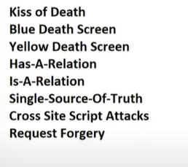

* Tables are not SEO friendly.

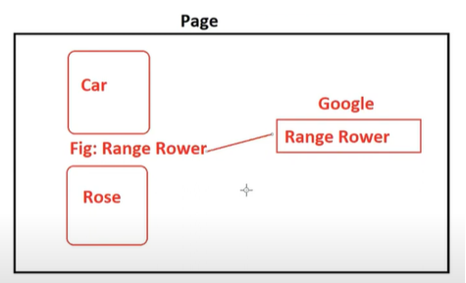

* Html 5 introduced new elements into body section to design a layout that can be SEO friendly.
* The new elements of html 5 body section are:

1. aside – information not related to our website like ads.
2. article – highlights of our website.
3. dialog
4. figure
5. figcaption
6. header
7. footer
8. section
9. main
10. nav
11. menu
12. div
13. span

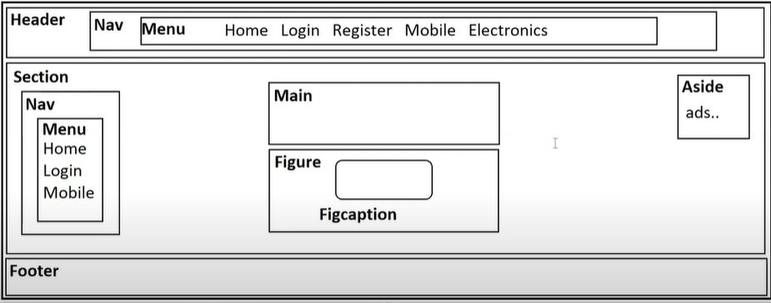

* All are containers

<aside>

--your content

</aside>

* Div defines blocked content
* Span defines inline content

* <body vlink="gray" alink="red">
* <h1>Welcome to HTML</h1>
* <div>Topic -1</div>
* <div>Topic -2</div>
* <div>Topic -3</div>
* </body>
* <div>

Welcome to HTML . It is a markup language , For more dettials visit <span>Click here</span>

</div>

* 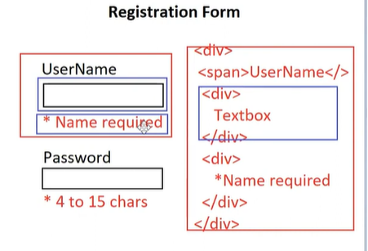
* <!DOCTYPE html>
* <html lank="en-in">
* <head>
* <title>Pinsu | Website</title>
* <link rel="shortcut icon" href="favicon.ico">
* <meta name="viewport" content="width=device-width ,initial-scale=1">
* <!-- <meta http-equiv="refresh" content="1"> -->
* <style>
* span {
* color: red;
* }
* header,footer{
* background-color: tomato;
* color: white;
* text-align: center;
* }
* section{
* height: 500px;
* }
* </style>
* </head>
* <body vlink="gray" alink="red">
* <h1>Welcome to HTML</h1>
* <header>
* Amazon Shoping
* </header>
* <section>
* <nav>
* <menu>
* <div>Home</div>
* <div>Electronics</div>
* <div>FootWear</div>
* </menu>
* </nav>
* <main>
* Shiping Main content
* <article>
* 50 % Off on Electronics
* </article>
* <figure>
* Image header
* <figcaption>Fig:Mobile</figcaption>
* </figure>
* </main>
* <aside>
* Ads here..
* </aside>
* </section>
* <footer>
* copyright 2022
* </footer>
* </body>
* </html>

**Session-05**

Body section and its elements:

1. aside – information not related to our website like ads.
2. article – highlights of our website.
3. dialog
4. figure
5. figcaption
6. header
7. footer
8. section
9. main
10. nav
11. menu
12. div
13. span
14. Add <style> container in head section

<head>

<style>

</style

</Head>

1. You can add styles into styles container

Selector

{

Attribute : value;

Attribute : value;

}

Note: selector defines where you want to apply effects, to which element.

Style Attribute:

* background-color : set background color
* color : set text color
* text-align : set alignment left,center,right,justify
* border : set border

[size , style,color]

Border:2px solod|dotted|dashed| red

* margin-left,right,top,bottom
* margin : all directions
* padding-left,right,top,bottom
* padding : all directions.
* border-radius : curved border[pixels];
* height : height of element
* width : width of element

Distribute contents into multiple columns:

display:gird

grid-template-columns: how many columns and their size. Max 12 columns.

Note: columns width in pixels or fractions

Pixels : max 12000px fixed size

Fr : max 12 fr adjust according to browser

EX:

<!DOCTYPE html>

<html>

    <head>

        <title>Layout</title>

        <style>

            header,footer{

                background-color: tomato;

                color: white;

                text-align: center;

                padding:15px;

                border: 3px dashed black;

                border-radius: 10px;

            }

            section{

                height: 400px;

                display: grid;

                grid-template-columns: 3fr 7fr 2fr;

                margin-top: 20px;

            }

            figure{

                height: 150px;

                width: 100px;

                border: 2px dotted red;

                padding: 10px;

            }

            aside{

                border:2px dotted red;

                height: 70px;

                padding: 20px;

            }

            article{

                background-color: red;

                width: 200px;

                color:white;

                padding:10px;

                border: 2px solid red;

                border-radius: 20px;

            }

            nav div{

                background-color: red;

                color: white;

                padding: 5px;

                margin-top: 10px;

                width:150px;

                border-radius: 20px;

                margin-left: -30px;

            }

        </style>

    </head>

    <body>

        <header>

            Amazon Shopping

        </header>

        <section>

            <nav>

                <menu>

                    <div>Home</div>

                    <div>Electronics</div>

                    <div>FootWear</div>

                    <div>Fashion</div>

                </menu>

            </nav>

            <main>

                <div>Shopping | online</div>

                <figure>

                    Image

                    <figcaption>Samsung TV</figcaption>

                </figure>

                <article>

                    Sale on 02-01-2024

                </article>

                <div>Sales</div>

            </main>

            <aside>

                ads...

            </aside>

        </section>

        <footer>

           &copy; copyright 2022

        </footer>

    </body>

</html>

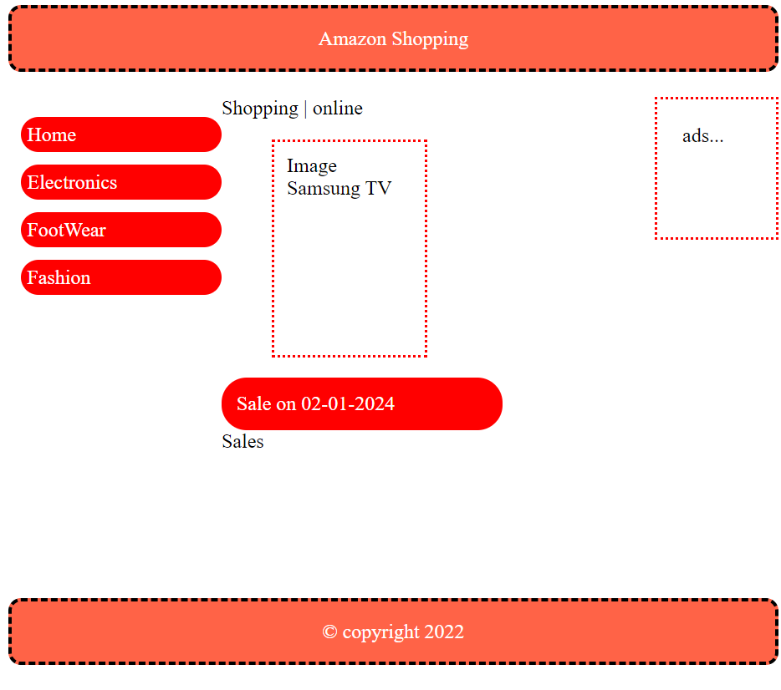

Text Effects

font-size : pixels

font-family : arial,times new roman,sans serif

font-weight :bold

font-style : italic

EX:

<!DOCTYPE html>

<html>

    <head>

        <title>Amazon Footer</title>

        <style>

            #back{

                background-color: slategray;

                color: white;

                text-align: center;

                padding: 10px;

                font-family: Arial, Helvetica, sans-serif;

                font-size: 20px;

                font-weight: bold;

            }

            footer{

                display: grid;

                grid-template-columns: 3fr 3fr 3fr 3fr;

                height: 300px;

                background-color: black;

                color: white;

                padding: 20px;

            }

            #title{

                font-family: Arial;

                font-weight: bold;

                font-size:16px;

            }

            #subtitles {

                margin-top: 20px;

                font-family: Arial;

            }

        </style>

    </head>

    <body>

        <div id="back">

            Back to Top

        </div>

        <footer>

            <div>

                <div id="title">Get To Know us</div>

            </div>

            <div>

                <div id="title">Connect with us</div>

                <div>

                    <div id="subtitles">Facebook</div>

                    <div id="subtitles">Twitter</div>

                    <div id="subtitles">Instagram</div>

                </div>

            </div>

            <div>

                <div id="title">Make money with us</div>

            </div>

            <div>

                <div id="title">Let us help you</div>

            </div>

        </footer>

    </body>

</html>

Output:

**Session-06**

Body section – elements

Columns can be defined by using :

1. display : grid – every columns is individual. Contents of one columns will not span to next column.
2. Columns – it is used for continuous columns. The content will span next column when it fits the previous column.

Syntax:

#container{

Columns : 2;

}

#container{

Display : grid;

Grid-template-columns : 3fr 6fr 3fr;

}

Vertical and Horizontal navigation:

---------------------------------------------

Vertical navigation:

EX:

<!DOCTYPE html>

<html>

    <head>

        <title>Columns</title>

        <style>

            nav div{

                border: 2px solid red;

                background-color: tomato;

                color: white;

                padding: 5px;

                margin-bottom: 20px;

                width:150px;

            }

        </style>

    </head>

    <body>

        <nav>

            <div>Home</div>

            <div>About</div>

            <div>Contact</div>

        </nav>

    </body>

</html>

EX: Horizontal navigation

<!DOCTYPE html>

<html>

    <head>

        <title>Columns</title>

        <style>

            nav div{

                border: 2px solid red;

                background-color: tomato;

                color: white;

                padding: 5px;

                margin-right: 50px;

                width:150px;

            }

            nav{

                display: flex;

            }

        </style>

    </head>

    <body>

        <nav>

            <div>Home</div>

            <div>About</div>

            <div>Contact</div>

        </nav>

    </body>

</html>

Responsive navigation:

* Navigation bar must change its orientation according to device screen.
* You can define it by using CSS @media queries.

Syntax:

@media  screen and (orientation : landscape) {

                nav{

                    display: flex;

                }

                nav div{

                    margin-right: 30px;

                }

            }

**Adding Icons to page :**

----------------------------

1. Download and install “bootstrap icons”

* Open terminal
* Switch to cmd
* Type the following commands

> npm install bootstrap-icons.

2. All icons are kept in a “.css” file .

3. you have to link the CSS file to webpage.

4. Every icon will have a class name , you have to apply by using “class” attribute.

<div class=”bi bi-house”>

Get help about icons from “www.getbootstrap.com”

EX:

1. Open Terminal

* Npm install bootstrap-icons –save

1. Go to html file and link stylesheet.

        <link rel="stylesheet" href="../node_modules/bootstrap-icons/font/bootstrap-icons.css">

1. You can apply icons to any container

<span class=”bi bi-alarm”>

<div class=”bi bi-alarm”>

EX:Position :Fixed

Top,botton.right,bottom

<!DOCTYPE html>

<html>

    <head>

        <title>Social Bar</title>

        <link rel="stylesheet" href="../node_modules/bootstrap-icons/font/bootstrap-icons.css">

         <style>

            nav div{

                margin-bottom: 10px;

                color: darkcyan;

            }

            nav{

                position: fixed;

                right:10px;

                bottom: 0px;

                background-color: rgba(255,255,255,0.4);

                padding: 20px;

            }

         </style>

    </head>

    <body>

        <nav>

            <div class="bi bi-facebook"></div>

            <div class="bi bi-twitter"></div>

            <div class="bi bi-linkedin"></div>

            <div class="bi bi-instagram"></div>

        </nav>

        My name is Pinsu singh

        My name is Pinsu singh

        My name is Pinsu singh

        My name is Pinsu singh

        My name is Pinsu singh

        My name is Pinsu singh

        My name is Pinsu singh

        My name is Pinsu singh

        My name is Pinsu singh

        My name is Pinsu singh

        My name is Pinsu singh

        My name is Pinsu singh

        My name is Pinsu singh

        My name is Pinsu singh

        My name is Pinsu singh

        My name is Pinsu singh

        My name is Pinsu singh

       </body>

       </html>

Mouse Over effect:

* You can apply by using “:hover”

Syntax:

Div{} -normal

Div :hover {} --on mouse over

EX:

<!DOCTYPE html>

<html>

    <head>

        <title>Navbar</title>

        <link rel="stylesheet" href="../node_modules/bootstrap-icons/font/bootstrap-icons.css">

        <style>

        nav div{

            border: 1px solid red;

            width:150px;

            margin-bottom: 20px;

            padding: 5px;

            border-radius: 20px;

            background-color: yellow;

            font-size: 20px;

            transition: 2s;

        }

        #icon{

            color: red;

            font-weight: bold;

        }

        nav div:hover{

            background-color: black;

            color: white;

            font-size: 20px;

            transition: 2s;

        }

        </style>

    </head>

    <body>

        <nav>

            <div>

                <span id="icon" class="bi bi-bell"></span> <span>Notification</span>

            </div>

            <div>

                <span id="icon" class="bi bi-alarm-fill"></span> <span>Alerts</span>

            </div>

            <div>

                <span id="icon" class="bi bi-youtube"></span> <span>Youtube</span>

            </div>

        </nav>

    </body>

</html>

**Session-07**

Body Section Literals:

1. Line breaks

<br>

FAQ: What is the difference between <br> and </br>.

Ans: No difference.

Html will not provide <br/>. It is just developers technique of writing void element.

1. Blank spaces

&nbsp; [non-breakable space]

1. Pre formatted text

<pre>

</pre>

EX:

<pre>

            #include &lt;stdio.h&gt;

            main()

            {

                printf("Welcome to Html");

            }

         </pre>

1. Variables

<var>

  var <var>x</var> = 10;

        <br>

        var <var>y</var> = 20;

        <br>

        var <var>z</var> = x+y;

1. Code snippet

<code>

Ex:

<!DOCTYPE html>

<html>

    <head>

        <title>Basic Element</title>

        <style>

            code{

                color:red;

                border: 2px solid red;

            }

        </style>

    </head>

    <body>

       <div>Invalid Operation</div>

       <code>Page not found - http://localhost:5500/public/contact.html</code>

    </body>

</html>

1. Titles for content

* Title is a screen tip display for text , image or any graphic.

EX:

       <code><span title="Page you requested not found">404*</span> - http://localhost:5500/public/contact.html</code>

1. Headings

<h1></h1> first level

…

<h6></h6> second level

* Heading can use aling attribute for left ,center ,right,or justify.

<h1 align=”center”>

* Don’t use headings to highlight any word or sentence in paragraph.
* Don’t use too many headings in page. It may lead to SPAM.

FAQ: Why to use heading element? Without heading we can apply similar effect.

Ans: To make the page topics SEO friendly.

FAQ: Can we change the font size and color or effects for heading?

Ans: Yes ,with styles.

EX:

<!DOCTYPE html>

<html>

    <head>

        <title>Basic Element</title>

        <style>

            h1{

                border: 2px solid red;

                background-color: yellow;

                color: red;

                padding:4px;

            }

        </style>

    </head>

    <body>

        <h1 align="center"> Web Technologies</h1>

       <h2>Html</h2>

        It is markup language

        <h2>JavaScript</h2>

        It is used as side script with html.

        <br><br>

        <h2>CSS</h2>

        It is used for styles.

    </body>

</html>

1. Paragraphs and blockquotes

<p> paragraph

<blockquote> blockquote

* You can align paragraphs by using left ,center right, justify.

EX:

<!DOCTYPE html>

<html>

    <head>

        <title>Basic Element</title>

        <style>

            blockquote{

                font-style: italic;

                color: gray;

                margin-left: 200px;

                margin-right: 200px;

            }

        </style>

    </head>

    <body>

        <h2>HTML</h2>

        <blockquote align="justify">

            sssssssssssssssssssssssssssssssssaaaaaaaaaaaaaaaawwwwwwwwwwwwwwwwwwwwww

        </blockquote>

        <div>

           <p aligh="justify"> Hi how are you hhhhhhhhhhhhhhhhhhhhhhhhhhhhhhhhhhhhhhhbbvvvvvvfffghhhhhhhhhhbjhjkkkkkkkkhhhhhhhhhhhhhhhhhvvvvvvvvvvvvvvvvvvvvvvvvvvvvvvvvvvvvvvhhhhhhhh</p>

           <p> Hi how are you</p>

           <p> Hi how are you</p>

           <p> Hi how are you</p>

        </div>

    </body>

</html>

**Session-08**

Data List in Html

* It is collection of terms and definitions.
* Terms are defined by using <dt>
* Definition defined by using <dd>
* Terms and definitions are defined in <dl>

Syntax:

<dl>

<dt>Term</dt>

<dd>Definition</dd>

<dt>Term</dt>

<dd>Definition</dd>

</dl>

EX:

<!DOCTYPE html>

<html>

    <head>

        <title>Terms and Definition</title>

        <style>

            dt{

                background-color: gray;

                color: white;

                padding: 4px;

                margin-bottom: 4px;

            }

        </style>

    </head>

    <body>

        <dl>

            <dt>HTML</dt>

            <dt>Hyper Text Markup Language</dt>

            <dd>It is markup language</dd>

            <dd>It is used for presentation</dd>

            <dt>CSS</dt>

            <dd>It is used to define styles.</dd>

            <dt>JavaScript</dt>

            <dd> It is used as language for interaction with HTML.

                <p align="justify">My friends People live in society. Hence we cannot identify with those who live near us and work with us. This acquaintance sometimes turns into friendship. You will not find friendless people. Even monks have friends. I also have friends. Peter is my close friend. He is my friend since childhood</p>

            </dd>

        </dl>

    </body>

</html>

EX:

<!DOCTYPE html>

<html>

    <head>

        <title>Terms and Definition</title>

        <style>

            dl{

                display: grid;

                grid-template-columns: 3fr 9fr;

            }

            dt{

                margin-bottom: 20px;

                background-color: gray;

                color:white;

                padding:4px;

            }

            dd{

                margin-bottom: 20px;

                background-color: lightgreen;

                color:black;

                padding:4px;

            }

        </style>

    </head>

    <body>

        <dl>

            <dt>Product Name</dt>

            <dd>Samsung TV</dd>

            <dt>Price</dt>

            <dd>5600.00</dd>

            <dt>Stock</dt>

            <dd>Available</dd>

        </dl>

    </body>

</html>

Ex:

<!DOCTYPE html>

<html>

    <head>

        <title>Terms and Definition</title>

        <style>

            dt{

                background-color: black;

                color: white;

                padding: 4px;

                width:200px;

                position: sticky;

                top:0px;

            }

        </style>

    </head>

    <body>

       <nav>

        <dl>

            <dt>Electronics</dt>

            <dd>Mobile</dd>

            <dd>Watch</dd>

            <dd>Watch</dd>

            <dd>Television</dd>

            <dd>Speakers</dd>

            <dt>FootWaer</dt>

            <dd>Sneakers</dd>

            <dd>Casuals</dd>

            <dd>Sneakers</dd>

            <dt>Fashion</dt>

            <dd>Women Wear</dd>

            <dd>Men Wear</dd>

            <dd>Women Wear</dd>

        </dl>

       </nav>

    </body>

</html>

**Details And Summary**:

* Details is a collapsable container.
* It is defined by using <details>
* Details container can contain any kind of information within the context.
* Details uses <summary> to display title for details you defined.

<details>

<summary> Title </summary>

…any content…

</details>

* You can use open attributes for details to keep the details open always.

<details open>

</details>

EX:

<!DOCTYPE html>

<html>

    <head>

        <title>Terms and Definition</title>

        <style>

        </style>

    </head>

    <body>

       <nav>

        <details>

            <summary>Electronics</summary>

            <dl>

                <dd>Telvision</dd>

                <dd>Mobile</dd>

                <dd>Watch</dd>

                <dd>Watch</dd>

                <dd>Television</dd>

                <dd>Speakers</dd>

            </dl>

        </details>

        <details open>

            <summary>Need Help</summary>

            <dl>

                <dd>Forgot password</dd>

                <dd>Gorgot user id</dd>

            </dl>

        </details>

       </nav>

    </body>

</html>

Fieldset and Legend :

* Fieldset is container with frame
* It is defined by using <fieldset>
* Every fieldset can have a <legend>
* Legend summarises the topic in fieldset

Syntax:

<fieldset>

<legend> Title </legend>

…your content…

</fieldset>

CSS Shadow:

* Box-shadow : it is used for any container
* Text-shadow : it is only for text.

Syntax:

box-shadow: hPixel , vPixel , blurPixel , color;

text-shadow: hPixel , vPixel , blurPixel , color;

EX:

<!DOCTYPE html>

<html>

    <head>

        <title>Terms and Definition</title>

        <style>

            dt{

                background-color: gray;

                color:white;

                margin-bottom: 20px;

                padding: 4px;

            }

            dl{

                display: grid;

                grid-template-columns: 3fr 9fr;

            }

            fieldset{

                margin-bottom: 20px;

                box-shadow: 5px 4px 5px black;

            }

            legend{

                background-color: yellow;

                color: red;

                padding: 4px;

                text-align: center;

                width: 150px;

                border:2px solid red;

                box-shadow: 5px 4px 5px black;

            }

            body{

                border:2px solid red;

                box-shadow: 5px 4px 5px black;

                padding: 30px;

                border-radius: 40px;

            }

        </style>

    </head>

    <body>

        <fieldset>

            <legend>Pesonal information</legend>

            <dl>

                <dt>First Name</dt>

                <dd>Pinsu</dd>

                <dt>Last Name</dt>

                <dd>Singh</dd>

                <dt>Fathers Name</dt>

                <dd>Shree Lokesh Sharma</dd>

            </dl>

        </fieldset>

        <fieldset>

            <legend>Address Information</legend>

            <dl>

                <dt>City</dt>

                <dd>Pune</dd>

                <dt>State</dt>

                <dd>Maharastra</dd>

                <dt>Postal Code</dt>

                <dd>8623823</dd>

            </dl>

        </fieldset>

    </body>

</html>

EX:

<!DOCTYPE html>

<html>

    <head>

        <title>Terms and Definition</title>

        <style>

            h1{

                font-size: 60px;

                text-align:center;

                border:2px solid red;

                text-shadow: 3px 4px 5px black;

                color:yellow;

                padding: 10px;

            }

        </style>

    </head>

    <body>

       <h1>Web Technologies</h1>

    </body>

</html>

**Ordered List :**

* It is used for auto numbering.
* It is configured by using <ol>
* It comprises of collection of items defined with <li>.

Syntax:

<ol>

<li> Item-1</li>

<li> Item-2 </li>

</ol>

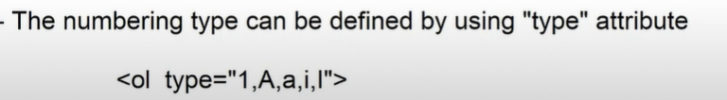

A-Z ,AA,AB,AC…..

* You can define level number to start with.

<ol start=”5”>

<ol type=”a” start=”5”>

* You can also reverse numbering

<ol reversed>

3,2,1,0,-1,-2…

c,b,a,0,-1,-2…

**Session-09**

Nested Ordered List : Configruing a list within another list.

EX:

<!DOCTYPE html>

<html>

    <head>

        <title>Terms and Definition</title>

        <style>

        </style>

    </head>

    <body>

       <ol>

        <li>Html

            <ol type="a">

                <li>Normal Elements</li>

                <li>Void Elements</li>

            </ol>

        </li>

        <li>JavaScript

            <ol type ="a">

                <li>Variables

                    <ol type="i">

                        <li>Var</li>

                        <li>let</li>

                    </ol>

                </li>

                <li>Data Types</li>

            </ol>

        </li>

       </ol>

    </body>

</html>

Note: You have to configure a <ol> with in <li> not below.

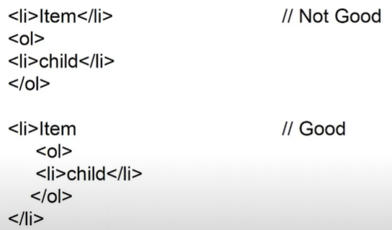

FAQ: How to design List items side by side?

Ans: By using “display:flex”

EX:

<!DOCTYPE html>

<html>

    <head>

        <title>Terms and Definition</title>

        <style>

            #child {

                display: flex;

                margin-bottom: 20px;

            }

            li{

                margin-right: 40px;

                margin-top: 10px;

            }

        </style>

    </head>

    <body>

       <ol type="I">

            <li>

                The element that will not return presentation directly are known as ___________.

                <ol type="a" id="child">

                    <li>Noraml Emlement</li>

                    <li>Void Element</li>

                    <li>RC Data</li>

                    <li>Raw Text</li>

                </ol>

            </li>

            <li>

                The raw text elements are __________.

                <ol type="a" id="child">

                    <li>Bold</li>

                    <li>image</li>

                    <li>&Copy</li>

                    <li>Italic</li>

                </ol>

            </li>

       </ol>

    </body>

</html>

FAQ: How to define list item in multiple columns?

Ans: display :grid or columns

FAQ: How to design a scrollable list ?

Ans: By overflow attribute.

EX:

<!DOCTYPE html>

<html>

    <head>

        <title>Terms and Definition</title>

        <style>

            ol{

                border: 2px solid black;

                height:150px;

                width:150;

                overflow: auto;

            }

        </style>

    </head>

    <body>

       <ol>

        <li>HTML</li>

        <li>CSS</li>

        <li>Bootstrap</li>

        <li>JQueru</li>

        <li>HTML</li>

        <li>CSS</li>

        <li>Bootstrap</li>

        <li>JQueru</li>

        <li>HTML</li>

        <li>CSS</li>

        <li>Bootstrap</li>

        <li>JQueru</li>

        <li>HTML</li>

        <li>CSS</li>

        <li>Bootstrap</li>

        <li>JQueru</li>

        <li>HTML</li>

        <li>CSS</li>

        <li>Bootstrap</li>

        <li>JQueru</li>

        <li>HTML</li>

        <li>CSS</li>

        <li>Bootstrap</li>

        <li>JQueru</li>

       </ol>

    </body>

</html>

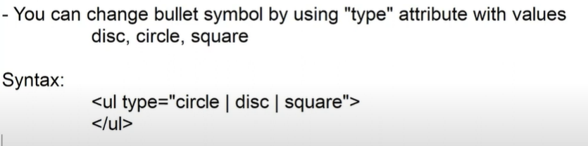

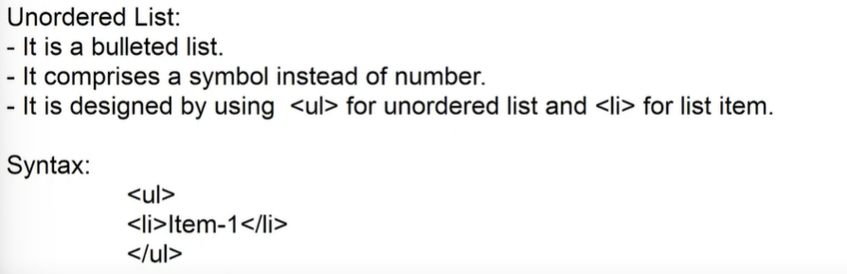

FAQ: How to define custom bullet symbols ?

Ans: By using CSS property “list-style-image”

[It can be applied for both <ul> and <ol>]

FAQ: How to remove bullet or numbered sysmbol for list.

Ans: CSS property “list-style : none”

EX:

<!DOCTYPE html>

<html>

    <head>

        <title>Terms and Definition</title>

        <style>

            ul{

                list-style: none;

            }

            li{

                background-color: yellow;

                padding: 4px;

                width: 140px;

                margin-bottom: 20px;

            }

            li:hover{

                background-color: black;

                color: white;

            }

        </style>

    </head>

    <body>

       <nav>

        <ul>

            <li>Home</li>

            <li>About</li>

            <li>Contact</li>

        </ul>

       </nav>

    </body>

</html>

FAQ: Can we define different symbols for each list item individually ?

Ans: NO.You have to use external icons library[boot strap icins].

EX:

<!DOCTYPE html>

<html>

    <head>

        <title>Terms and Definition</title>

        <style>

            ul{

                list-style: none;

            }

            li{

                background-color: yellow;

                padding: 4px;

                width: 140px;

                margin-bottom: 20px;

            }

            li:hover{

                background-color: black;

                color: white;

            }

        </style>

        <link rel="stylesheet" href="../node_modules/bootstrap-icons/font/bootstrap-icons.css">

    </head>

    <body>

       <nav>

        <ul>

            <li><span class="bi bi-house"></span> Home</li>

            <li><span class="bi bi-person"></span> About</li>

            <li><span class="bi bi-facebook"></span> Contact</li>

        </ul>

       </nav>

    </body>

</html>

**Session-10**

1. Font

* <font> element is used to change the character

1. Face
2. Size
3. Color

* Font face is the name of font family for character.

Syntax: <font face="Brush script MT">

            Web Technologies

       </font>

FAQ: What are web safe fonts ?

Ans: Web safe fonts are the standard fonts available for all devices.

The standard web safe fonts are:

1. monospace
2. sans-serif
3. serif

* Font size can be defined in 7 levels.
* From 1 to 7

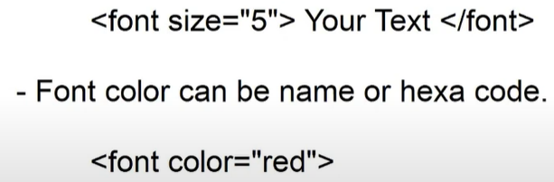

1. Font Styles

Bold <b>

Strong <strong>

Italic <i>

Emphasized <em>

FAQ: What is difference between **bold** and **strong** ?

Ans:

<b> is used in design mode to highlight

<strong> is used in review mode .

<i> is for design and <em> for review.

EX:

       <p>The <b>Bold</b> effect is similar to <strong>Strong</strong></p>

1. Font Effects

<u> Underline

<ins> Inserted -Underline

<strike> Strikeout

<del> Deleted-Strikeout [Review]

<sup> superscript

<sub> subscript

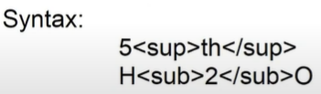

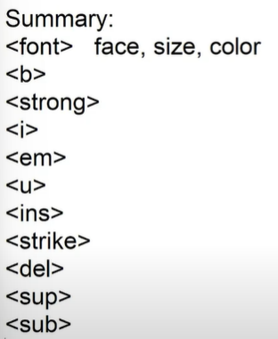

EX:

<!DOCTYPE html>

<html>

    <head>

        <title>Text</title>

        <style>

            #product{

                display: grid;

                grid-template-columns: 3fr 6fr 3fr;

            }

            #rating{

                background-color: green;

                color: white;

                padding: 5px;

                border-radius: 5px;

                margin-right: 5px;

            }

            div{

                margin-bottom: 10px;

                font-family: Arial;

            }

            ul{

                margin-left: -20px;

            }

            li{

                color:gray;

                margin-bottom: 10px;

            }

        </style>

        <link rel="stylesheet" href="../node_modules/bootstrap-icons/font/bootstrap-icons.css">

    </head>

    <body>

       <div id="product">

        <div>

            image here..

        </div>

        <div>

            <div><font size="5" face="Arial" color="blue">realme Narzo 50A(Oxygen Green , 64 GB)</font></div>

            <div><span id="rating">4.4 <span class="bi bi-star-fill"></span></span> <span></span><font color="gray" size="4">2, 04,460 rating & 14,500 reviews</font></div>

            <ul>

                <li>swdefwokdjsxaswoe</li>

                <li>swdefwokdjsxaswoe</li>

                <li>swdefwokdjsxaswoe</li>

                <li>swdefwokdjsxaswoe</li>

                <li>swdefwokdjsxaswoe</li>

            </ul>

        </div>

        <div>

            <b><font size="5">&#8377; 11,549</font></b>

            <div><p><strike>&#8377;12,999</strike><span><font color="green">11% Off</font></span></p></div>

            <div><font>Free delivery</font></div>

        </div>

       </div>

    </body>

</html>

**Session-11**

Images in HTML

* Images are of various types.
* Web supports only few types.
* MIME is “Multipurpose Internet Mail Extensions”.

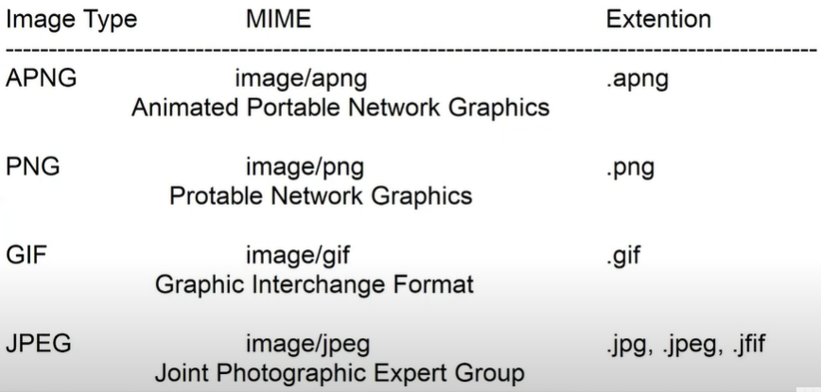

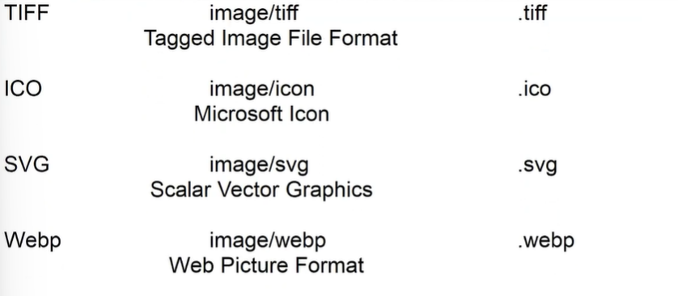

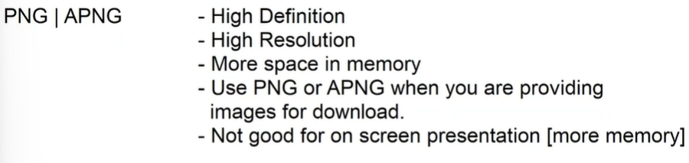



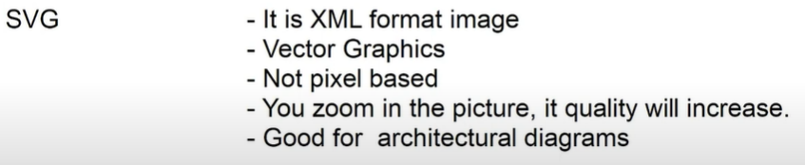

* You can embed images into web page by using <img> element.
* It is void element.

<img>

**Attributes** :

1. alt : it specifies the the alternatives text to display when image fails to load.
2. Src : it refers to the path and name of image.

Synatx:

<img alt=”some text” src=”..path”>

1. Title : it refers to the screen tip to display when mouse is over image.

Synatx:

<img alt=”some text” src = “..path” title=”message”>

1. Width : it specifies width of image in pixels or percentage.
2. Height : it specifies height of image in pixels or percentage.

NOTE: size in % will adjust according to the browser.

It often called as “Fluid-image”

<img width=”300”>

<img width =”50%”>

1. Align : it aligns the image left or right . Align is used to wrap text around.

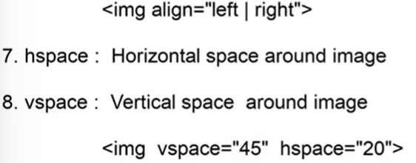

1. Border : sets border for image.

<img border= “2”>

**Advanced Attributes :**

1. crossorigin : it is used when image is accessed from remote server.

crossorigin = “anonymous | use credentials”

1. decoding : it defines how image have to load along with other contents.

decoding = async | sync

sync : load image and block others.

async : it defines the priority of image.

1. importance : it defines the priority of image

importance = low ,high, auto

**Session-12**

Cards Design with Images and Styles

* Flexible design

1. display:flex
2. flex-wrap:wrap - it will not disturb the size of element.

EX:

<!DOCTYPE html>

<html>

    <head>

        <title>Cards</title>

        <link rel="stylesheet" href="../node_modules/bootstrap-icons/font/bootstrap-icons.css">

    </head>

    <style>

        .card{

            width: 150px;

            padding: 20px;

            margin: 20px;

            box-shadow: 3px 3px 3px gray;

            text-align: center;

            font-family: Arial;

        }

        .card-image{

            width: 100px;

            height: 140px;

        }

        .card-header{

            margin-top: 20px;

            font-weight: bold;

        }

        .card-body{

            margin-top: 20px;

            color:goldenrod

        }

        .card-footer{

            margin-top: 2px;

            color:blueviolet;

        }

        .container{

            display: flex;

            flex-wrap: wrap;

        }

    </style>

    <body>

        <div class="container">

            <div class="card">

                <img class="card-image" src="../assets/card1.jpg" alt="">

                <div class="card-header">

                    UI Technologies online training

                </div>

                <div class="card-body">

                    <span class="bi bi-star-fill"></span>

                    <span class="bi bi-star-fill"></span>

                    <span class="bi bi-star-fill"></span>

                    <span class="bi bi-star-fill"></span>

                    <span class="bi bi-star-fill"></span>

                </div>

                <div class="card-footer">

                    View Course

                </div>

            </div>

            <div class="card">

               <img class="card-image" src="../assets/card2.jpg" alt="">

               <div class="card-header">

                DevOps Technologies online training

            </div>

            <div class="card-body">

                <span class="bi bi-star-fill"></span>

                <span class="bi bi-star-fill"></span>

                <span class="bi bi-star-fill"></span>

                <span class="bi bi-star-fill"></span>

                <span class="bi bi-star-fill"></span>

            </div>

            <div class="card-footer">

                View Course

            </div>

            </div>

            <div class="card">

                <img class="card-image" src="../assets/card3.jpg" alt="">

                <div class="card-header">

                    AWS online training

                </div>

                <div class="card-body">

                    <span class="bi bi-star-fill"></span>

                    <span class="bi bi-star-fill"></span>

                    <span class="bi bi-star-fill"></span>

                    <span class="bi bi-star-fill"></span>

                    <span class="bi bi-star-fill"></span>

                </div>

                <div class="card-footer">

                    View Course

                </div>

            </div>

            <div class="card">

                <img class="card-image" src="../assets/card4.jpg" alt="">

                <div class="card-header">

                    DataScience online training

                </div>

                <div class="card-body">

                    <span class="bi bi-star-fill"></span>

                    <span class="bi bi-star-fill"></span>

                    <span class="bi bi-star-fill"></span>

                    <span class="bi bi-star-fill"></span>

                    <span class="bi bi-star-fill"></span>

                </div>

                <div class="card-footer">

                    View Course

                </div>

            </div>

            <div class="card">

                <img class="card-image" src="../assets/card5.jpg" alt="">

                <div class="card-header">

                    Spring Boot online training

                </div>

                <div class="card-body">

                    <span class="bi bi-star-fill"></span>

                    <span class="bi bi-star-fill"></span>

                    <span class="bi bi-star-fill"></span>

                    <span class="bi bi-star-fill"></span>

                    <span class="bi bi-star-fill"></span>

                </div>

                <div class="card-footer">

                    View Course

                </div>

            </div>

        </div>

    </body>

</html>

EX:

<!DOCTYPE html>

<html>

    <head>

        <title>Demo</title>

    </head>

    <style>

        .text-effects{

            color: red;

            text-align: center;

        }

        .back-effects{

            background-color: yellow;

        }

        .border-effects{

            border: 2px solid red;

        }

    </style>

    <body>

        <h1 class="text-effects back-effects border-effects">Welcome</h1>

        <p class="back-effects">HI</p>

    </body>

</html>

[www.fakestoreapi.com/products](http://www.fakestoreapi.com/products)

EX:

<!DOCTYPE html>

<html>

    <head>

        <title>Demo</title>

    </head>

    <link rel="stylesheet" href="../node_modules/bootstrap-icons/font/bootstrap-icons.css">

    <style>

        .card{

            width:200px;

            padding: 10px;

            margin:20px;

            box-shadow: 3px 3px 3px gray;

        }

        .card-image{

            width: 100px;

            height:150px;

        }

        dl{

            display: grid;

            grid-template-columns: 3fr 9fr;

        }

        dt{

            margin-top: 10px;

        }

        .card-header{

            height: 50px;

            text-align: center;

        }

    </style>

    <body>

        <div class="container">

            <div class="card">

                <img class="card-image" src="https://fakestoreapi.com/img/81fPKd-2AYL._AC_SL1500_.jpg" alt="">

                <div class="card-header">

                    <h3>BackPack</h3>

                </div>

                <div class="card-body">

                    <dl>

                        <dt>Price</dt>

                        <dd>&#8377; 4300.44</dd>

                        <dt>Rating</dt>

                        <dd>

                                    <span class="bi bi-star-fill"></span>

                                    <span class="bi bi-star-fill"></span>

                                    <span class="bi bi-star-fill"></span>

                                    <span class="bi bi-star-fill"></span>

                                    <span class="bi bi-star-half"></span>

                        </dd>

                    </dl>

                </div>

                <div class="card-footer">

                    <button>

                        <span class="bi bi-cart4"></span>

                        Add to cart

                    </button>

                </div>

            </div>

                <div class="card">

                    <img class="card-image" src="https://fakestoreapi.com/img/71YXzeOuslL._AC_UY879_.jpg" alt="">

                    <div class="card-header">

                        <h3>Mens Tshirt</h3>

                    </div>

                    <div class="card-body">

                        <dl>

                            <dt>Price</dt>

                            <dd>&#8377; 7000.44</dd>

                            <dt>Rating</dt>

                            <dd>

                                <span class="bi bi-star-fill"></span>

                                    <span class="bi bi-star-fill"></span>

                                    <span class="bi bi-star-fill"></span>

                                    <span class="bi bi-star-fill"></span>

                                    <span class="bi bi-star-half"></span>

                            </dd>

                        </dl>

                    </div>

                    <div class="card-footer">

                        <button>

                            <span class="bi bi-cart4"></span>

                            Add to cart

                        </button>

                    </div>

                </div>

                    <div class="card">

                        <img class="card-image" src="https://fakestoreapi.com/img/51UDEzMJVpL._AC_UL640_QL65_ML3_.jpg" alt="">

                        <div class="card-header">

                            <h3>Jwellary</h3>

                        </div>

                        <div class="card-body">

                            <dl>

                                <dt>Price</dt>

                                <dd>&#8377; 55000.44</dd>

                                <dt>Rating</dt>

                                <dd>

                                    <span class="bi bi-star-fill"></span>

                                    <span class="bi bi-star-fill"></span>

                                    <span class="bi bi-star-fill"></span>

                                    <span class="bi bi-star-fill"></span>

                                    <span class="bi bi-star-half"></span>

                                </dd>

                            </dl>

                        </div>

                        <div class="card-footer">

                            <button>

                                <span class="bi bi-cart4"></span>

                                Add to cart

                            </button>

                        </div>

            </div>

        </div>

    </body>

</html>

* To keep content center on page.
* Display : flex;
* Justify-content : cenetr; Horizontal alignment
* Align-items:center; Vertical alignment

Ex:

<!DOCTYPE html>

<html>

    <head>

        <title>Center</title>

    </head>

    <style>

        body{

           background-color: black;

           color: white;

           font-family: Arial;

        }

        .main{

            width: 500px;

            text-align: center;

        }

        h1{

            width: 400px;

            text-align: center;

        }

        h3{

            width:400px;

            text-align:center;

        }

        p{

            text-align: center;

        }

        .container{

            display: flex;

            justify-content: center;

            align-items: center;

            height:600px;

        }

        .main{

            background-color: rgba(0,0,0,0.5);

            padding: 5px;

        }

    </style>

    <body background="../assets/netflix2.jpg">

        <div class="container">

            <div class="main">

                <h1>Unlimited movies, TV shows and more</h1>

                <h3>Watch anywhere. Cancel anytime.</h3>

                <p>Ready to watch? Enter your email to create or restart your membership.</p>

            </div>

        </div>

    </body>

</html>

**Session-13**

**Links in HTML**

* Link is clickable text , picture or graphic that navigates the user to any specific location.
* Every website must have good navigation techniques.
* You can configure navigation using Links in HTML page.
* Links in webpage are also refferes as “Hyper Link”.
* Links are classified into two types

1. Intra document links
2. Inter document links

* Intra document links allow navigation from one location to another within the same page.
* Inter document links allow navigation from one document to another.
* Links are created by using <a> anchor element.

Intra Document Links:

* Configures navigation from one location to another location within same page.
* You have to define a unique ID for target location.

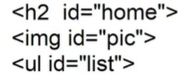

* User can reach to specific location by requesting the id reference from URL



* You can configure <a> anchor element that can reach to id.

<a href=”#home”> Text | Image | Symbol </a>

FAQ: How can we change color for Links ?

Ans: By using CSS classes

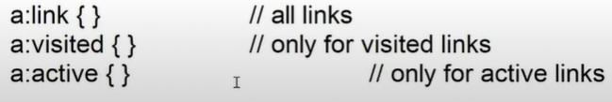

a{} // all states normal, visited ,active

FAQ: How to remove underline for Hyperlink ?

Ans : By using “text-decoration : none”

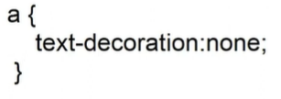

FAQ: How to set underline on mouse over ?

Ans : By using “hover” class.

a{

text-decoration: underline;

}

<!DOCTYPE html>

<html>

    <head>

        <title>Shopping</title>

        <style>

            header{

                background-color: black;

                color: white;

                text-align: center;

                font-size: 30px;

                padding: 10px;

            }

            section{

                display: grid;

                grid-template-columns: 3fr 9fr;

            }

            ul{

                list-style:none;

                margin-left:-40px;

            }

            li{

                background-color: black;

                color:white;

                padding: 5px;

                margin-bottom: 20px;

                width:140px;

            }

            main{

                height: 600px;

                overflow: auto;

            }

             nav a {

                color: white;

                text-decoration: none;

            }

            span a{

                text-decoration: none;

                color: red;

                font-weight: bold;

            }

            a:hover{

                text-decoration: underline;

            }

        </style>

    </head>

    <body>

        <header>Shopping Online</header>

        <section>

            <nav>

                <ul>

                    <li><a href="#home">Home</a></li>

                    <li><a href="#electronics">Electronics</a></li>

                    <li><a href="#footwear">FootWear</a></li>

                    <li><a href="#fashion">Fashion</a></li>

                </ul>

            </nav>

            <main>

                <h2 id="home">Home</h2>

                <p>A paragraph has three major parts- 1. Topic <span><a href="#mobile">Visit Mobile</a></span> sentence 2. Supporting sentences 3. Concluding sentence 1. Topic Sentence A topic sentence is a precise statement that reflects the main idea of the paragraph. It should be carefully written as it will show the reader what you are going to talk about. Words chosen for this</p>

                <p>A paragraph has three major parts- 1. Topic sentence 2. Supporting sentences 3. Concluding sentence 1. Topic Sentence A topic sentence is a precise statement that reflects the main idea of the paragraph. It should be carefully written as it will show the reader what you are going to talk about. Words chosen for this</p>

                <p>A paragraph has three major parts- 1. Topic sentence 2. Supporting sentences 3. Concluding sentence 1. Topic Sentence A topic sentence is a precise statement that reflects the main idea of the paragraph. It should be carefully written as it will show the reader what you are going to talk about. Words chosen for this</p>

                <p>A paragraph has three major parts- 1. Topic sentence 2. Supporting sentences 3. Concluding sentence 1. Topic Sentence A topic sentence is a precise statement that reflects the main idea of the paragraph. It should be carefully written as it will show the reader what you are going to talk about. Words chosen for this</p>

                <p>A paragraph has three major parts- 1. Topic sentence 2. Supporting sentences 3. Concluding sentence 1. Topic Sentence A topic sentence is a precise statement that reflects the main idea of the paragraph. It should be carefully written as it will show the reader what you are going to talk about. Words chosen for this</p>

                <p>A paragraph has three major parts- 1. Topic sentence 2. Supporting sentences 3. Concluding sentence 1. Topic Sentence A topic sentence is a precise statement that reflects the main idea of the paragraph. It should be carefully written as it will show the reader what you are going to talk about. Words chosen for this</p>

                <h2 id="electronics">Electronics</h2>

                <img src="../assets/iphone.webp" width="100" height="100">

                <img src="../assets/mobile.webp" width="100" height="100">

                <p>A paragraph has three major parts- 1. Topic sentence 2. Supporting sentences 3. Concluding sentence 1. Topic Sentence A topic sentence is a precise statement that reflects the main idea of the paragraph. It should be carefully written as it will show the reader what you are going to talk about. Words chosen for this</p>

                <p>A paragraph has three major parts- 1. Topic sentence 2. Supporting sentences 3. Concluding sentence 1. Topic Sentence A topic sentence is a precise statement that reflects the main idea of the paragraph. It should be carefully written as it will show the reader what you are going to talk about. Words chosen for this</p>

                <p>A paragraph has three major parts- 1. Topic sentence 2. Supporting sentences 3. Concluding sentence 1. Topic Sentence A topic sentence is a precise statement that reflects the main idea of the paragraph. It should be carefully written as it will show the reader what you are going to talk about. Words chosen for this</p>

                 <figure>

                    <figcaption id="mobile" >Mobile</figcaption>

                    <img src="../assets/mobile2.webp" width="150" height="200">

                    <div>

                        <a href="#home">Back to Home</a>

                    </div>

                </figure>

                <p>A paragraph has three major parts- 1. Topic sentence 2. Supporting sentences 3. Concluding sentence 1. Topic Sentence A topic sentence is a precise statement that reflects the main idea of the paragraph. It should be carefully written as it will show the reader what you are going to talk about. Words chosen for this</p>

                <p>A paragraph has three major parts- 1. Topic sentence 2. Supporting sentences 3. Concluding sentence 1. Topic Sentence A topic sentence is a precise statement that reflects the main idea of the paragraph. It should be carefully written as it will show the reader what you are going to talk about. Words chosen for this</p>

                <p>A paragraph has three major parts- 1. Topic sentence 2. Supporting sentences 3. Concluding sentence 1. Topic Sentence A topic sentence is a precise statement that reflects the main idea of the paragraph. It should be carefully written as it will show the reader what you are going to talk about. Words chosen for this</p>

                <h2 id="footwear">FootWear</h2>

                <img src="../assets/shoe.jpg" width="100" height="100">

                <img src="../assets/shoe.jpg" width="100" height="100">

                <p>A paragraph has three major parts- 1. Topic sentence 2. Supporting sentences 3. Concluding sentence 1. Topic Sentence A topic sentence is a precise statement that reflects the main idea of the paragraph. It should be carefully written as it will show the reader what you are going to talk about. Words chosen for this</p>

                <p>A paragraph has three major parts- 1. Topic sentence 2. Supporting sentences 3. Concluding sentence 1. Topic Sentence A topic sentence is a precise statement that reflects the main idea of the paragraph. It should be carefully written as it will show the reader what you are going to talk about. Words chosen for this</p>

                <p>A paragraph has three major parts- 1. Topic sentence 2. Supporting sentences 3. Concluding sentence 1. Topic Sentence A topic sentence is a precise statement that reflects the main idea of the paragraph. It should be carefully written as it will show the reader what you are going to talk about. Words chosen for this</p>

                <p>A paragraph has three major parts- 1. Topic sentence 2. Supporting sentences 3. Concluding sentence 1. Topic Sentence A topic sentence is a precise statement that reflects the main idea of the paragraph. It should be carefully written as it will show the reader what you are going to talk about. Words chosen for this</p>

                <p>A paragraph has three major parts- 1. Topic sentence 2. Supporting sentences 3. Concluding sentence 1. Topic Sentence A topic sentence is a precise statement that reflects the main idea of the paragraph. It should be carefully written as it will show the reader what you are going to talk about. Words chosen for this</p>

                <p>A paragraph has three major parts- 1. Topic sentence 2. Supporting sentences 3. Concluding sentence 1. Topic Sentence A topic sentence is a precise statement that reflects the main idea of the paragraph. It should be carefully written as it will show the reader what you are going to talk about. Words chosen for this</p>

                <h2 id="fashion">Fashion</h2>

                <img src="../assets/card1.jpg" width="100" height="100">

                <img src="../assets/card2.jpg" width="100" height="100">

                <p>A paragraph has three major parts- 1. Topic sentence 2. Supporting sentences 3. Concluding sentence 1. Topic Sentence A topic sentence is a precise statement that reflects the main idea of the paragraph. It should be carefully written as it will show the reader what you are going to talk about. Words chosen for this</p>

                <p>A paragraph has three major parts- 1. Topic sentence 2. Supporting sentences 3. Concluding sentence 1. Topic Sentence A topic sentence is a precise statement that reflects the main idea of the paragraph. It should be carefully written as it will show the reader what you are going to talk about. Words chosen for this</p>

                <p>A paragraph has three major parts- 1. Topic sentence 2. Supporting sentences 3. Concluding sentence 1. Topic Sentence A topic sentence is a precise statement that reflects the main idea of the paragraph. It should be carefully written as it will show the reader what you are going to talk about. Words chosen for this</p>

                <p>A paragraph has three major parts- 1. Topic sentence 2. Supporting sentences 3. Concluding sentence 1. Topic Sentence A topic sentence is a precise statement that reflects the main idea of the paragraph. It should be carefully written as it will show the reader what you are going to talk about. Words chosen for this</p>

                <p>A paragraph has three major parts- 1. Topic sentence 2. Supporting sentences 3. Concluding sentence 1. Topic Sentence A topic sentence is a precise statement that reflects the main idea of the paragraph. It should be carefully written as it will show the reader what you are going to talk about. Words chosen for this</p>

                <p>A paragraph has three major parts- 1. Topic sentence 2. Supporting sentences 3. Concluding sentence 1. Topic Sentence A topic sentence is a precise statement that reflects the main idea of the paragraph. It should be carefully written as it will show the reader what you are going to talk about. Words chosen for this</p>

            </main>

        </section>

    </body>

</html>

FAQ: If content is not scrollable then how to highlight the active topic ?

Ans : By using CSS “target” class.

.topic{

Gray , white

}

.topic:target{

Define color etc …

}

EX for target:

<!DOCTYPE html>

<html>

    <head>

        <title>Tutorial</title>

        <style>

            .topics{

                border: 1px solid black;

                background-color: lightgray;

                padding: 10px;

                margin-bottom: 20px;

            }

            .topics:target{

                background-color: black;

                color: white;

            }

            nav{

                background-color: black;

                color: white;

                padding: 5px;

                margin-bottom: 10px;

            }

            li{

                display: inline;

                margin-right: 40px;

            }

            a{

                color: white;

                font-size: 20px;

                text-decoration: none;

            }

        </style>

    </head>

    <body>

        <nav>

            <ul>

                <li><a href="#html">HTML</a></li>

                <li><a href="#css">CSS</a></li>

                <li><a href="#js">JavaScript</a></li>

            </ul>

        </nav>

        <div class="topics" id="html">

            <h2>HTML</h2>

            <p>It is a markup language.</p>

        </div>

        <div class="topics" id="css">

            <h2>CSS</h2>

            <p>It defines styles.</p>

        </div>

        <div class="topics" id="js">

            <h2>JavaScript</h2>

            <p>It is a programming language.</p>

        </div>

    </body>

</html>

**Session-14**

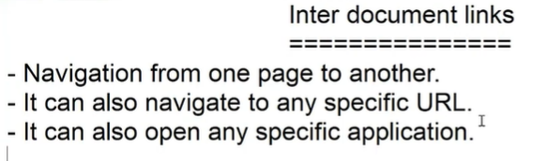

* It can also open any specific application.

Note :

* The target file will open in browser or download it depends on plugins



Ex :

<!DOCTYPE html>

<html>

    <head>

        <title>Links</title>

    </head>

    <body>

        <ol>

            <li><a href="shopping.html">Shopping Page</a></li>

            <li><a href="http://www.amazon.in">Online Shopping</a></li>

            <li><a href="../assets/shoe.jpg">Nike Casuals</a></li>

            <li><a href="./docs/Html.docx">Tutorial HTML</a></li>

            <li><a href="./docs/JavaScript.docx">Tutorial JavaScript</a></li>

        </ol>

    </body

</html>

FAQ : How to design a link that always downloads even when plugin is available.

Ans: By using “download” attribute for <a>

Syntax:

<a href="../assets/shoe.jpg" download="nike">Nike Casuals</a>

FAQ: How do you link to any application ?

Ans: By using “href” with following attributes.

* mailto : email app
* tel : phone dail app
* skype : skype app
* javascript : for any another app or function

Syntax

<li>Contact Our <a href="mailto:hr@infy.com">hr@infy.com</a></li>

            <li>Call <a href="tel:8709330502">8709330502</a></li>



FAQ: How to open link in a new tab ?

Ans : by using “target” attribute set to “_blank”.

Target = _blank , _search , _self ,_parent

FAQ : How to open link in a new window ?

Ans : By using “javascript” window.open() method.



EX:

<li><a href="javascript:window.open('../assets/shoe.jpg' , 'Nike','width = 500 height=500')">Nike Casuals</a></li>

FAQ: How to open in same window along with existing content?

Ans: By using <iframe> of html , that uses target attribute with frame name.

* Iframe is used to embed any external content into page , which can be image , video , animation , document, etc ..

Syntax :

<iframe src=”filepath”></iframe>

EX:

<!DOCTYPE html>

<html>

    <head>

        <title>Links</title>

        <style>

            .container{

                display: grid;

                grid-template-columns: 3fr 9fr;

            }

            iframe{

                width: 500px;

                height: 500px;

                border: none;

            }

        </style>

    </head>

    <body>

        <div class="container">

            <nav>

                <ol>

                    <li><a href="shopping.html" target="bodyFrame">Shopping Page</a></li>

                    <li><a href="http://www.amazon.in">Online Shopping</a></li>

                    <li><a href="../assets/shoe.jpg" target="bodyFrame">Nike Casuals</a></li>

                    <li><a href="./docs/Html.docx">Tutorial HTML</a></li>

                    <li><a href="./docs/JavaScript.docx">Tutorial JavaScript</a></li>

                    <li>Contact Our <a href="mailto:hr@infy.com">hr@infy.com</a></li>

                    <li>Call <a href="tel:8709330502">8709330502</a></li>

                </ol>

            </nav>

            <main>

                <iframe name="bodyFrame"></iframe>

            </main>

        </div>

    </body

</html>

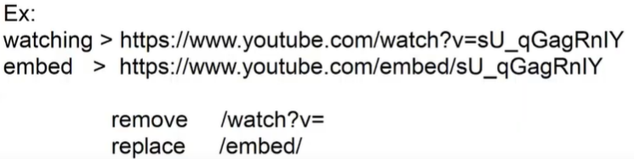

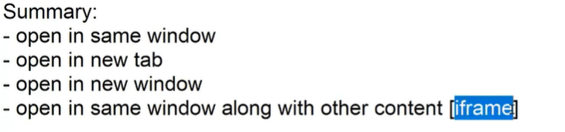

Assignment:

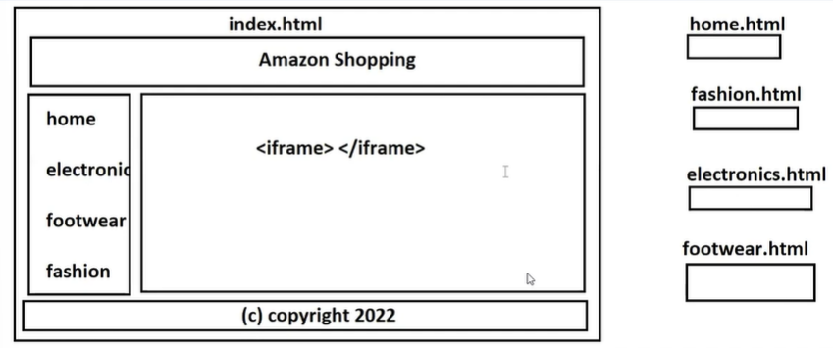

**Session-15**

**Tables In HTML :**

* Tables are used to store data in rows and columns.
* Tables Elements are

<table>

<caption>

<thead>

<tbody>

<tfoot>

<colgroup>

<tr>

<th>

<td>

EX:

<!DOCTYPE html>

<html>

    <head>

        <title>Product Details</title>

    </head>

    <body>

        <table width="500" border="1">

            <caption>Product Details</caption>

            <colgroup span="1" style="background-color: yellow;"></colgroup>

            <thead>

                <tr>

                    <th>Name</th>

                    <th>Price</th>

                    <th>Stock</th>

                    <th>Preview</th>

                </tr>

            </thead>

            <tbody>

                <tr>

                    <td>Speaker</td>

                    <td>5600.00</td>

                    <td>Available</td>

                    <td>

                        <img src="../assets/mobile.webp" widht="60" height="60">

                    </td>

                </tr>

                <tr>

                    <td>Shoe</td>

                    <td>4600.00</td>

                    <td>Available</td>

                    <td>

                        <img src="../assets/shoe.jpg" widht="60" height="60">

                    </td>

                </tr>

            </tbody>

            <tfoot>

                <tr>

                    <td>&nbsp;</td>

                    <td>&nbsp;</td>

                    <td>&copy; copyright 2024</td>

                    <td>&nbsp;</td>

                </tr>

            </tfoot>

        </table>

    </body>

</html>

Table Attribute:

1. Border , Frame and Rules

Frame : it is used for table ,you can apply values .

box | rhs | lhs | above |below | void

Syntax:

<table frame=”box”>

Rules :It is used for rows , columns and groups

rows | cols | groups | none

Synatx :

<table frame= ”box” rules = “groups ”>

Border : it is used for cell . it can have values 0 and 1.

0 = false[no border]

1 = true[border]

> 1 = 1.

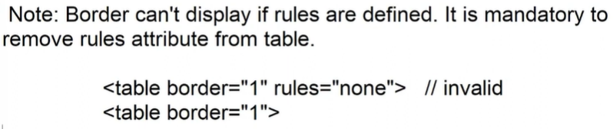

1. Cellspacing and cellpadding

Cellsapcing : it sets space between cells.

Cellspadding : it sets space between border and content.

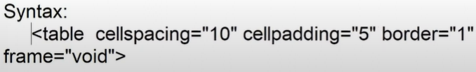

1. bgcolor and background

bgcolor : sets background color for table , group, row or cell.

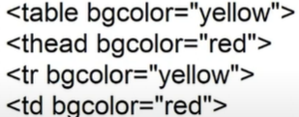

Background :sets

EX:

<style>

           tbody tr:nth-child(odd){

                background-color: red;

            }

            tbody tr:nth-child(even){

                background-color: green;

            }

        </style>

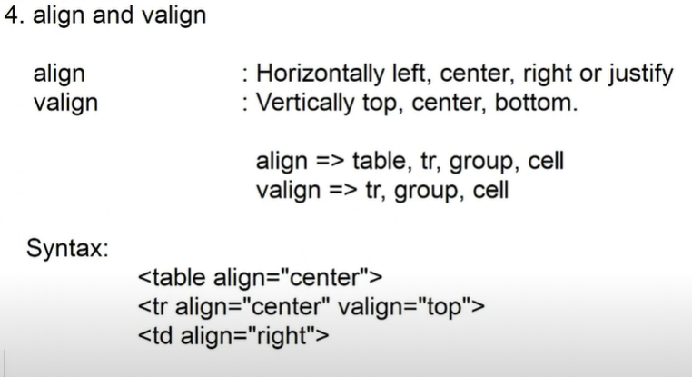

1. width and height

width : it sets width for table and cell.

height : it sets height for table , group , row, cell.

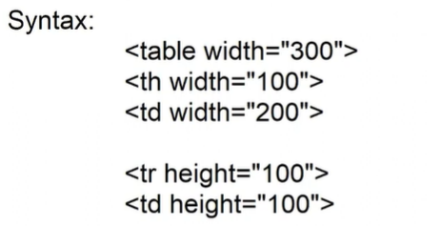

EX:

<!DOCTYPE html>

<html>

    <head>

        <title>Product Details</title>

    </head>

    <body>

        <table width="600" "cellspacing="10" cellpadding="10" border="1" frame="void" rules="all">

            <caption>Product Details</caption>

            <colgroup spa="2"></colgroup>

            <thead>

                <tr rules="" height="200">

                    <th width="100">Name</th>

                    <th>Price</th>

                    <th width="360">Stock</th>

                    <th>Preview</th>

                </tr>

            </thead>

            <tbody>

                <tr align="center">

                    <td>Speaker</td>

                    <td>5600.00</td>

                    <td>Available</td>

                    <td>

                        <img src="../assets/mobile.webp" widht="60" height="60">

                    </td>

                </tr>

                <tr>

                    <td>Shoe</td>

                    <td>4600.00</td>

                    <td>Available</td>

                    <td>

                        <img src="../assets/shoe.jpg" widht="60" height="60">

                    </td>

                </tr>

                <tr>

                    <td>Shoe</td>

                    <td>4600.00</td>

                    <td>Available</td>

                    <td>

                        <img src="../assets/shoe.jpg" widht="60" height="60">

                    </td>

                </tr>

                <tr>

                    <td>Shoe</td>

                    <td>4600.00</td>

                    <td>Available</td>

                    <td>

                        <img src="../assets/shoe.jpg" widht="60" height="60">

                    </td>

                </tr>

            </tbody>

            <tfoot>

                <tr>

                    <td>&nbsp;</td>

                    <td>&nbsp;</td>

                    <td>&copy; copyright 2024</td>

                    <td>&nbsp;</td>

                </tr>

            </tfoot>

        </table>

    </body>

</html>

1. colspan and rowspan :

**Session-16**

**Nested Tables**

* you can define a table inside another table

<tr>

<td>

<table>

</table>

</td>

</tr>

EX:

<!DOCTYPE html>

<html>

    <head>

        <title>Tables</title>

        <style>

            body{

                font-family: Arial;

            }

            a{

                text-decoration: none;

            }

            td img{

                width:100%;

                height:100%;

            }

            td {

                box-shadow: 2px 2px 2px gray;

            }

        </style>

    </head>

    <body>

        <table border="1" width="100%" frame="void" cellspacing="30">

            <tr height="300">

                <td>

                    <table cellspacing="20" width="100%">

                        <tr>

                            <td colspan="2">

                                <h2>Revamp your home in style</h2>

                            </td>

                        </tr>

                        <tr>

                            <td>

                                <img src="../assets/pic.jpg" alt="">

                                <p>Womens Fashion</p>

                            </td>

                            <td>

                                <img src="../assets/pic1.jpg" alt="">

                                <p>Mens Fashion</p>

                            </td>

                        </tr>

                        <tr>

                            <td>

                                <img src="../assets/pic2.jpg" alt="">

                                <p>Beuty</p>

                            </td>

                            <td>

                                <img src="../assets/pic3.jpg" alt="">

                                <p>Home</p>

                            </td>

                        </tr>

                        <tr>

                            <td colspan="2">

                                <a href="#">Explore All</a>

                            </td>

                        </tr>

                    </table>

                </td>

                <td>

                    <table width="100%">

                        <tr>

                            <td colspan="2">

                                <h2>Revamp your home in style</h2>

                            </td>

                        </tr>

                        <tr>

                            <td>

                                <img src="../assets/pic.jpg" alt="">

                                <p>Womens Fashion</p>

                            </td>

                            <td>

                                <img src="../assets/pic1.jpg" alt="">

                                <p>Mens Fashion</p>

                            </td>

                        </tr>

                        <tr>

                            <td>

                                <img src="../assets/pic2.jpg" alt="">

                                <p>Beuty</p>

                            </td>

                            <td>

                                <img src="../assets/pic3.jpg" alt="">

                                <p>Home</p>

                            </td>

                        </tr>

                        <tr>

                            <td colspan="2">

                                <a href="#">Explore All</a>

                            </td>

                        </tr>

                    </table>

                </td>

                <td>

                    <table width="100%">

                        <tr>

                            <td colspan="2">

                                <h2>Revamp your home in style</h2>

                            </td>

                        </tr>

                        <tr>

                            <td>

                                <img src="../assets/pic.jpg" alt="">

                                <p>Womens Fashion</p>

                            </td>

                            <td>

                                <img src="../assets/pic1.jpg" alt="">

                                <p>Mens Fashion</p>

                            </td>

                        </tr>

                        <tr>

                            <td>

                                <img src="../assets/pic2.jpg" alt="">

                                <p>Beuty</p>

                            </td>

                            <td>

                                <img src="../assets/pic3.jpg" alt="">

                                <p>Home</p>

                            </td>

                        </tr>

                        <tr>

                            <td colspan="2">

                                <a href="#">Explore All</a>

                            </td>

                        </tr>

                    </table>

                </td>

            </tr>

        </table>

    </body>

</html>

**Forms in HTML**

* Form is a container that provides various controls to interact with application and data.
* Form provides an UI for interaction like view , edit , update , insert and delete.
* Form comprises of various types of controls like
* buttons
* textbox
* checkbox
* radio
* listbox etc..

Form Container:

* Form container is designed by using form tag

<form>

</form>

* Form comprises of various attributes

1. name
2. id
3. class

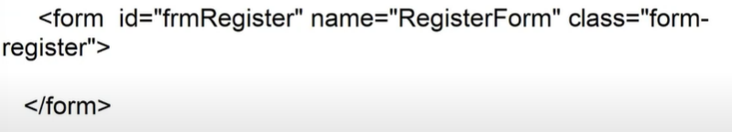

1. method : it defines the actions performed by form.

HTML form can be designed for 2 methods.

1. GET
2. POST

GET – it is used to fetch the data from server

POST – it is used to submit information to server

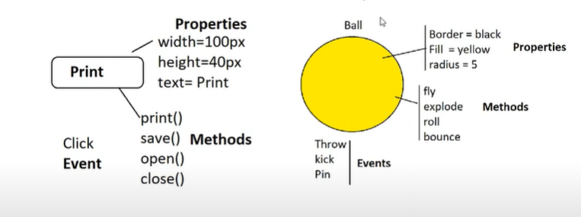

Note : The default method for form is GET.

FAQ : Can we submit information on GET ?

Ans: Yes , but not recommended.

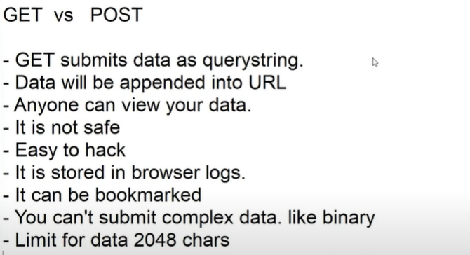

* You can cache the data [buffer].
* You can view data faster , it saves round trips.

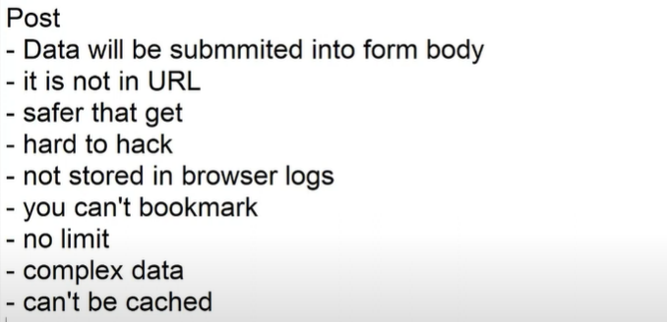

**Session – 17**

Attributes :

1. Id
2. Name
3. Class
4. Method
5. Action : indicates the target location where the data need to be submitted.

Syntax :

<form method=”post” action=”server page”>

EX:

<form method = “post” action=”page.jsp”>

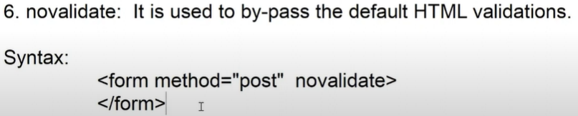

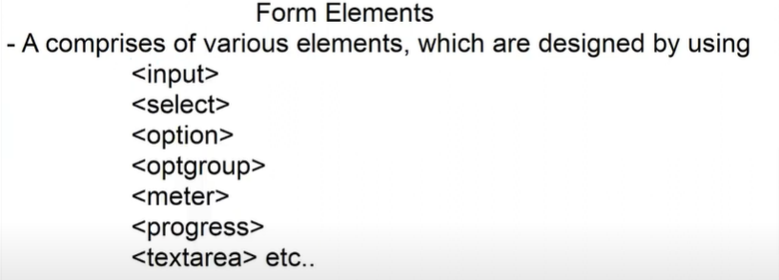

* Textbox attributes :

1. id
2. name
3. class

Note : Every element in form must have a “name” defined . If name is not defined then form cant submit its value.

1. value : the default value in text box.
2. readonly : it will not allow to change the value , but its submit the value.
3. Disabled : it will not allow to change and submit.



1. Size : it specifies the width of text box[20 default].

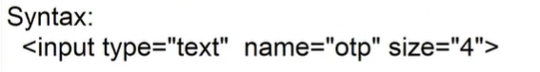

1. Autofocus : it sets focus to the control automatically.
2. Placeholder : it allows water mark text.
3. Minlength: it validates the minimum number of charas
4. Maxlength : it validates maximum number of chars.

It will not allow to exceeding the chars.

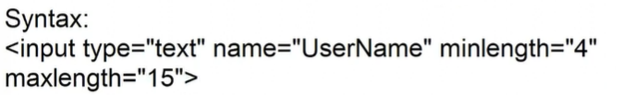

1. required : it will not allow to submit empty. It is used to define mandatory field.
2. List : it uses a data list

Data list is used as auto complete text.

Note: Data List is designed by using <datalist>

Data list contains options designed by using <option>

Synatx :

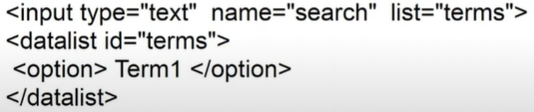

EX:

<form align="center">

            <h2>Googler</h2>

            <input type="text" list="terms" name="search" size="40">

            <datalist id="terms">

                <option>JavaScript Tutorial</option>

                <option>HTML</option>

                <option>CSS Example</option>

                <option>JavaScript Example</option>

                <option>HTML Example</option>

            </datalist>

            <p>

                <button>Searach</button>

            </p>

        </form>

1. pattern : it is used to restrict the format of value entered into text box.

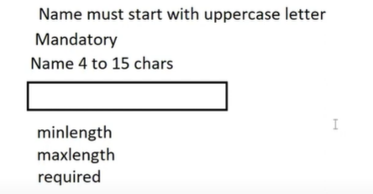

Meta Characters :

? zero or one occurrence of characters.

**Session-18**